**Full name: Bùi Trung Đức (Sửa lại theo front sheet mẫu)**

**Student ID: BHAF190100**



**FINAL ASSIGNMENT**

**Module: DataBase**

**Lecturer: Ngo Thi Mai Loan**

**Date of Submission: 19th** **June2020**

**TABLE OF CONTENTS**

You must use font *Calibri size 12, set number of the pages and use multiple line spacing at 1.3. Margins must be: left: 1.25 cm; right: 1 cm; top: 1 cm and bottom: 1 cm.*

**Introduction………………………………… ……………………………… 4**

**I. Basic SQL………………………………………………………………… 4**

**1. Data structure concept …………………………………………..16**

**2. RDBMS……………………………………………………………………17**

**3. Constraint in SQL:…………………………………………………..17**

**4. Datatypes in database…………………………………………….17**

**5. Standardized Data. …………………………………………………18**

**II. Design relational database system……………………...18**

**1. ERD………………………………………………………………….18**

**2. Design database……………………………………………....19**

**3. Code to SQL Server……………………………………………20**

**III. Practice……………………………………………………………….29**

1. **Form Login…………………………………………………………33**
2. **Selecting the function will go to the Library Management page……………………………………………………………………36**
3. **Form Library Manage………………………………………….36**
4. **Form Serch………………………………………………………….38**
5. **Form Add…………………………………………………………….40**
6. **Form Delete…………………………………………………………43**
7. **Form Update……………………………………………………….43**

**IV. User manual**

1. **Login…………………………………………………………………….44**
2. **Form LibraryManagement…………………………………….46**
3. **View Bill_Book……………………………………………………..50**

**V. Conclusion……………………………………………………………….51**

You must use font *Calibri size 12, set number of the pages and use multiple line spacing at 1.3. Margins must be: left: 1.25 cm; right: 1 cm; top: 1 cm and bottom: 1 cm.*

**What is a database? What types of database are there?**

**Database is also known as platform data or database. A database is an organized collection of data. This is a collection of schemas, tables, queries, reports, and other objects.**

**Database is also known as platform data or database. A database is an organized collection of data. This is a collection of schemas, tables, queries, reports, and other objects.**

**Characteristics of Database (abbreviated as database)**

**A database is a collection of data logically linked to each other and has a certain meaning.**

**Commonly designed for a specific purpose with a group of users.**

**Can be understood in a simpler way, for example with a web application, there will be 3 parts:**

**1. Code programmed by the programmer: This is the part that helps the website work according to the intention of the website owner.**

**2. Multimedia data section (Media): Video, image and other user data files.**

**3. Database part: It is a place to store all text content, posts posted by website's admin. For example, save product description, save company introduction, save order information, etc.**

Introduction (Không ai trình bày để toàn chữ in đậm thế này, sai hết font chữ theo brief)

**In this report, I will present some basic concepts about databases, data types and how to standardize databases. This is also a report on the design of relational database systems with appropriate tools and techniques for a company.**

**I. Basic SQL**.

**SQL is a computer language, which helps to store and retrieve data stored in a relational database. SQL stands for Structured Query Language, a structured query language.**

**1. Data structure concept**

**- SQL stands for Structured Query Language, a structured query language, that allows you to access and manipulate databases to create, delete, modify, and extract data.**

**- SQL is also the standard language for relational database systems. All database management systems (RDBMS) such as MySQL, MS Access, Oracle, Sybase, Informix, Postgres or SQL Server all take SQL as the standard database language.**

**2. RDBMS.**

**- A relational database is a digital database based on the relational model of data, as proposed by E. F. Codd in 1970.[1] A software system used to maintain relational databases is a relational database management system (RDBMS). Many relational database systems have an option of using the SQL (Structured Query Language) for querying and maintaining the database.[2]**

**- RDBMS stands for Relational Database Management System - is the basis for SQL, and for all modern database systems such as MS SQL Server, IBM DB2, Oracle, MySQL and Microsoft Access.**

**- Table: Data in a RDBMS stored in database objects is called tables. This table is basically a collection of related data entries and it includes many columns and rows. Table is the most common and simple form of data storage in a relational database.**

**- A relational database refers to a database that stores data in a structured format, using rows and columns. This makes it easy to locate and access specific values within the database. It is "relational" because the values within each table are related to each other.**

**- Tables may also be related to other tables. The relational structure makes it possible to run queries across multiple tables at once.**

**- Record or a row: A record is also called a data row that is each individual item that exists in a table.**

**- A value NULL: A field with a NULL value is an invalid field. It is important that a value NULL differs from zero or a field containing spaces.**

**3. Constraint in SQL:**

**- Constraints can be specified when the table is created with the CREATE TABLE statement, or after the table is created with the ALTER TABLE statement.**

**- Constraint are rules enforced on data columns on a table. They are used to limit the type of data that can be inserted into a table. This ensures the accuracy and reliability of data in the database.**

**The following are some of the most common constraints used in SQL:**

**+ NOT NULL: Make sure that a column cannot be NULL.**

**+ DEFAULT: Provides a default value for a column when nothing is specified.**

**+ UNIQUE: Ensure that all values in a column are different.**

**+ PRIMARY Key: Specifies each row / record to be unique in a database table.**

**+ FOREIGN Key: Defines a row / record to be unique in any other database table.**

**+ CHECK: check constraint ensures that all values in a column satisfy certain conditions.**

**+ INDEX: Used to create and retrieve data from the database very quickly.**

**4. Datatypes in database.**

**Character string data type in SQL Server:**

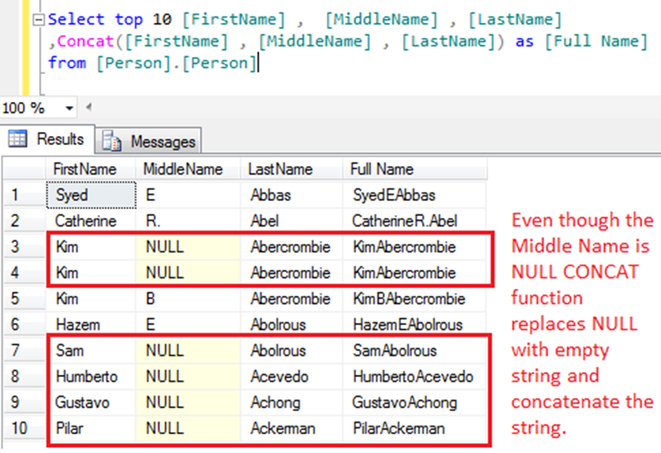

**String data types:**

**Data type Description Max size**

**varchar(n) Variable width character string 8,000 characters**

**varchar(max) Variable width character string 1,073,741,824 characters**

**text Variable width character string 2GB of text data**

**nchar Fixed width Unicode string 4,000 characters**

**VARCHAR(size) Maximum of 8000 characters. -Customized length.**

**-Does not contain Unicode characters.**

**TEXT Up to 2GB. -Customized length.**

**-Does not contain Unicode characters.**

**NCHAR(size) Maximum of 4000 characters. - Fixed length.**

**-Chicode character.**

**NVARCHAR(size) Maximum of 4000 characters or maximum number. -Customized length.**

**-Chicode character.**

**NTEXT Maximum of 1,073,741,823 bytes. -Customized length.**

**-Chicode character.**

**Date and time data types in SQL:**

**MySQL comes with the following data types for storing a date or a date/time value in the database:**

**DATE - format YYYY-MM-DD**

**DATETIME - format: YYYY-MM-DD HH:MI:SS**

**TIMESTAMP - format: YYYY-MM-DD HH:MI:SS**

**YEAR - format YYYY or YY**

**SQL Server comes with the following data types for storing a date or a date/time value in the database:**

**DATE - format YYYY-MM-DD**

**DATETIME - format: YYYY-MM-DD HH:MI:SS**

**SMALLDATETIME - format: YYYY-MM-DD HH:MI:SS**

**TIMESTAMP - format: a unique number**

**Note: The date types are chosen for a column when you create a new table in your database!**

**Exact Numeric data type:**

**Datatypes Start from To**

**bigint -9,223,372,036,854,775,808 9,223,372,036,854,775,807**

**int -2,147,483,648 2,147,483,647**

**smallint -32,768 32,767**

**tinyint 0 255**

**bit 0 1**

**decimal -10^38 +1 10^38 -1**

**money -922,337,203,685,477.5808 +922,337,203,685,477.5807**

**5. Standardized Data.**

**Standardizing the database is for two purposes:**

**- "Standardize" redirects here. For industrial and technical standards, see Standardization.**

**- "Z-score" redirects here. For Fisher z-transformation in statistics, see Fisher transformation. For Z-values in ecology, see Z-value. For z-transformation to complex number domain, see Z-transform. For Z-factor in high-throughput screening, see Z-factor. For Z-score financial analysis tool, see Altman Z-score.**

**- In statistics, the standard score is the number of standard deviations by which the value of a raw score (i.e., an observed value or data point) is above or below the mean value of what is being observed or measured. Raw scores above the mean have positive standard scores, while those below the mean have negative standard scores.**

**- It is calculated by subtracting the population mean from an individual raw score and then dividing the difference by the population standard deviation. This process of converting a raw score into a standard score is called standardizing or normalizing (however, "normalizing" can refer to many types of ratios; see normalization for more).**

**- Standard scores are most commonly called z-scores; the two terms may be used interchangeably, as they are in this article. Other terms include z-values, normal scores, and standardized variables.**

**6. Types of database normalization:**

**Standard 1NF:**

**- First normal form (1NF) is a property of a relation in a relational database. A relation is in first normal form if and only if the domain of each attribute contains only atomic (indivisible) values, and the value of each attribute contains only a single value from that domain.[1] The first definition of the term, in a 1971 conference paper by Edgar Codd, defined a relation to be in first normal form when none of its domains have any sets as elements.[2]**

**[2] [3] là cái gì? E copy-paste ở đâu có đọc hiểu nội dung của nó không?**

**- First normal form is an essential property of a relation in a relational database. Database normalization is the process of representing a database in terms of relations in standard normal forms, where first normal is a minimal requirement.**

**- First normal form enforces these criteria:[3]**

**+ Eliminate repeating groups[clarification needed] in individual tables**

**+ Create a separate table for each set of related data[definition needed]**

**+ Identify each set of related data with a primary key**

**Example:**

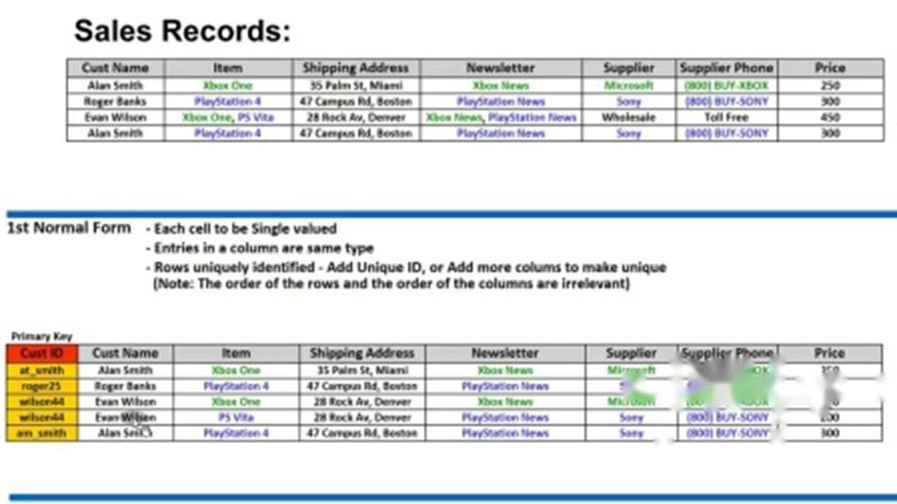

(Ảnh mờ nhòe thế này thì nhìn thấy gì hả em?)

(Cách dòng lung tung thế này à?)

**Standard 2NF:**

**A relationship in the normal form 2NF if that relationship:**

**+ It is in first normal form.**

**+ It does not have any non-prime attribute that is functionally dependent on any proper subset of any candidate key of the relation. A non-prime attribute of a relation is an attribute that is not a part of any candidate key of the relation.**

**+ Put simply, a relation is in 2NF if it is in 1NF and every non-prime attribute of the relation is dependent on the whole of every candidate key. Note that it does not put any restriction on the non-prime to non-prime attribute dependency. That is addressed in third normal form.**

**Target:**

**+Delete the subset of data in multiple rows of a table and place them in separate tables.**

**+Create relationships between new tables using foreign keys (foreign keys).**

**Example:**

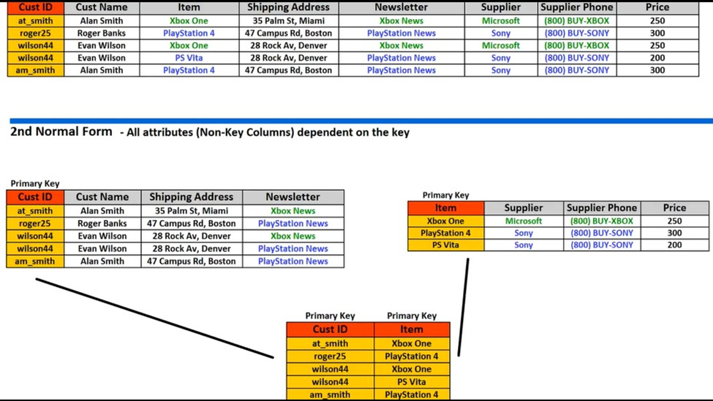

**To meet standard 2NF, it is necessary to divide the data table as follows:**

**Separate attributes (Founding and Class) into a separate table.**

**Separate attributes (ID_Cust ; Name_Cust) and (ID_Item, Name_Item)**

**into 2 tables.**

**Standard 3NF:**

**A relationship is in the normal form 3NF if the relationship satisfies the following conditions:**

**Third normal form (3NF) is a database schema design approach for relational databases which uses normalizing principles to reduce the duplication of data, avoid data anomalies, ensure referential integrity, and simplify data management. It was defined in 1971 by Edgar F. Codd, an English computer scientist who invented the relational model for database management.**

**A database relation (e.g. a database table) is said to meet third normal form standards if all the attributes (e.g. database columns) are functionally dependent on solely the primary key. Codd defined this as a relation in second normal form where all non-prime attributes depend only on the candidate keys and do not have a transitive dependency on another key.[1]**

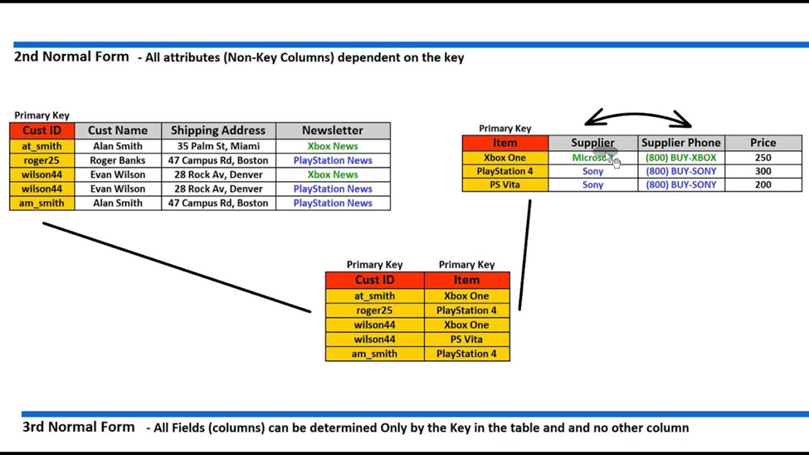

**Standardized rules from 2NF to 3NF:**

**+ Step 1: Removing dependent attributes bridging out of relationships and separating them into their own relationships with the key is the bridging attribute.**

**+ Step 2: The remaining properties form a relationship with the primary key being the original key.**

**(Cách lung tung)**

**Database Subject Definition**

**Database is a collection of organized data, usually stored and accessed electronically from a computer system. As databases are more complex, they are often developed using formal design and modeling techniques.**

**Database management system (DBMS) is software that interacts with end users, applications and the database itself to collect and analyze data. DBMS software includes core utilities provided for database administration. The total of databases, DBMS and related applications can be called "database systems". Often the term "database" is also used to refer to any DBMS, database system or application associated with the database.**

**Computer scientists can classify database management systems according to the database models they support. Relational databases became dominant in the 1980s. These model data are in the form of rows and columns in a series of tables and most use SQL (Structured Query Language). ) to record and query data. In the 2000s, relational databases became popular, called NoSQL because they used other query languages.**

**Design process**

**The design process includes the following steps:**

**Determine the purpose of the database**

**This will prepare you for the next steps. ( Copy ở đâu ra, đọc có hiểu gì ko? Sao lại có you ở đây?)**

**Find and organize the necessary information**

**Gather all sorts of information you may want to record in the database, such as product names and order numbers.**

**Divide information into tables**

**Divide the item into key entities or objects, like Products or Orders. Each object will then become a table.**

**Turn information items into columns**

**Decide what kind of information you want to store in each table. Each item becomes a field and is displayed as a column in the table. For example, an Employee table might contain fields like Last Name and Recruitment Date.**

**Specify the primary key**

**Choose a primary key for each table. The primary key is a column, used to identify individual rows. An example might be Product ID or Order ID.**

**Establish a relationship for the table**

**View the table and decide the relationship of the data in that table with data in other tables. Add fields to the table or create new tables to clarify relationships, if needed.**

**Refine your design**

**Analyze the design to find errors. Create the table and add some sample data records. See if you can get the desired results from the table. Proceed to design adjustments, if necessary.**

**Apply standardized rules**

**Apply data normalization rules to see if your table has been structured appropriately. Proceed to adjusting the table, if necessary.**

**➔ Information of objects (people, objects, concepts, events, etc.) stored on computers.**

**➔ Data is described in many different forms (characters, numbers, images, symbols, sounds ...). Each description is associated with a certain semantics.**

**➔ ➔ Object data may vary, depending on the context. For example, student data may vary depending on management purposes:**

**(Trình bày văn bản quá kém!)**

**➔ Point Management of grades: Name, student ID, grade 1, point 2, subject 3.**

**➔ Database is a collection of organized data related to each other and stored in computers.**

**➔ Database is designed and built to allow users to store data, retrieve information or update data.**

**➔ Database is organized structured: The data is stored structured into records, fields. The stored data has a relation (relation) to each other**

**➔ The database is structured for easy access, management and updating.**

**Database overview - Data management**

**Data management is the management of a large amount of data, including the storage and provision of mechanisms that allow manipulation (add, edit, delete data) and query data. Two data management methods: File management system and Database management system**

**???)**

**(Cách 1 khoảng này để làm gì?)**

**Data management by file**

**Data is stored in separate files. For example, programs store information using a system of text files.**

**Disadvantages of file management:**

**Redundancy and data inconsistencies.**

**Poor performance in random retrieval or concurrent processing.**

**Data discrete storage.**

**Having problems with safety and security**

**Data management by database**

**Managing data by database helps the data to be stored effectively and organized, allowing quick and effective data management.**

**Overview of databases - Database models**

**Data file model**

**Flat file databases are usually text files that contain tabular data. For example, a flat file shows information about Customer in the form of a table of Northwind Traders**

**(Đây là cái gì?Viêt không theo hàng cột thế này e có hiểu là cái gì ko?)**

**Customer ID Company Name Contact First Name Contact Last Name Job Title City State**

**6 Company F Francisco Pérez-Olaeta Purchasing Manager Milwaukee WI**

**26 Company Z Run Liu Accounting Assistant Miami FL**

**(Lại bỏ 2 khoảng trống)**

**Decentralized data model**

* **Organized in a tree, each node represents a data entity. Data contact is shown on the relationship between the parent node and the child node. Each parent node may have one or more children, but each child can only have one parent.**

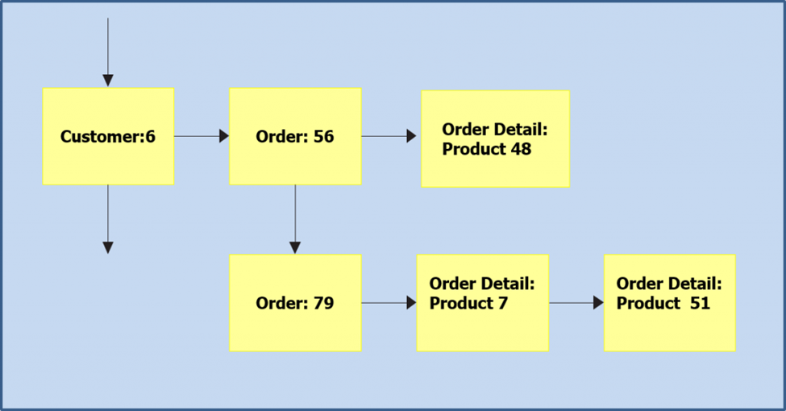

**Network data model**

**- The individual files in a flat file system are called records. A set of records of the same type constitute a data entity type. The entity types are connected to each other through a parent-child relationship. The network data model is represented by a directed graph, and the arrows point from the parent entity type to the child entity type.**

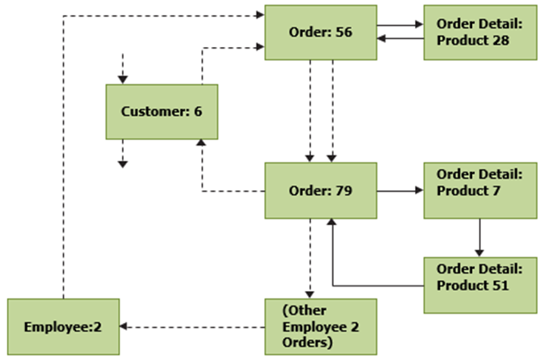

**Relational data model**

**In relational data model, there are no physical links. Data is represented in the form of tables with rows and columns: a database is a collection of tables (also called relationships). Each row is a record, also known as a tuple. Each column is an attribute, also known as a field.**

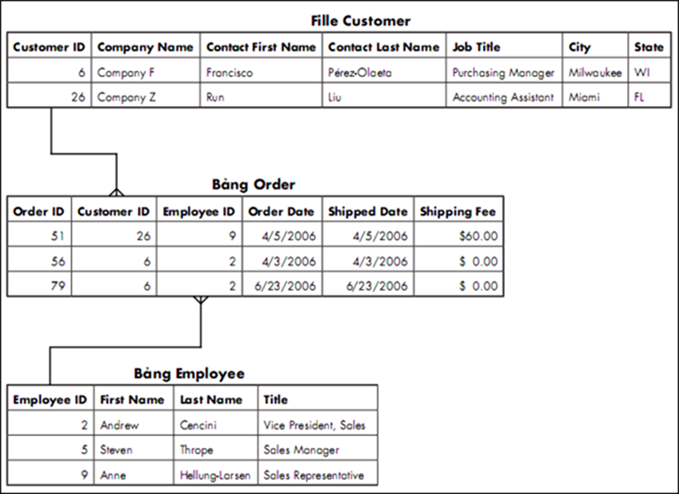

**Object-oriented data model**

**Each object includes attributes, methods (behaviors) of the object. Objects communicate with each other through methods. An object can be generated from inheritance from another object, overloaded (or redefined) the method of another object ...**

**(Copy trên mạng mà trình bày lung tung)**

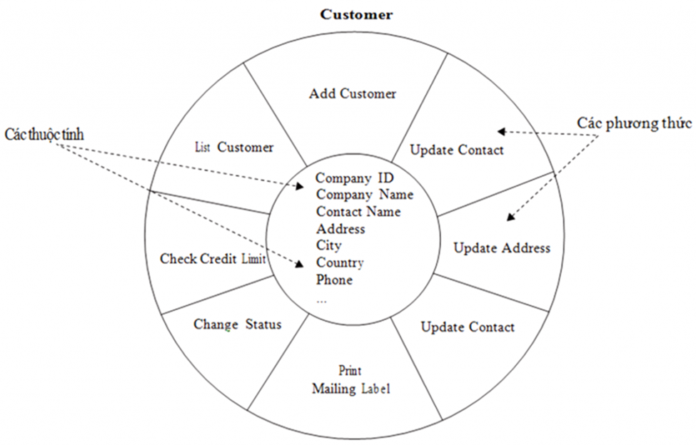

**(Đang tiếng anh lại có hình tiếng việt?)**

**Overview of databases - Database management system**

**Database models refer to organizational forms of data storage and access. Database management system (DataBase Management System - DBMS) is the software that helps create databases and provide storage and access mechanism according to database models.**

**For example, SQL Server, Microsoft Access, Oracle are typical database management systems for relational model. IBM IMS is the database management system for the decentralized model. IDMS is the database management system for network model**

**The benefits DBMS brings**

(Sai ngữ pháp)**Administer the database and provide access interface to hide complex features in terms of physical data structure. Support for communication languages. Example: Descriptive language, data definition - DDL. Data manipulation language - DML Structured data query language - SQL There is a mechanism of safety and security**

**(Đây đã đủ và đúng lợi ích của DBMS chưa? )**

**The disbenefits DBMS brings (Sai ngữ pháp)**

**• Excess data and inconsistencies**

**• Difficulties in accessing data**

**• Data isolation**

**• Atomicity problems**

**• Abnormalities in competitive traceability**

**• Security problems**

**Relational Data Management System (Relational DataBase Management System) (Viết 2 lần còn mở đóng ngoặc làm cái gì)**

**RDMBS is the most commonly used form of DBMS, in which all data is tightly organized in the form of data tables. All database operations take place on tables.**

**Users related to RDBMS**

(Sao để hình tiếng Việt?)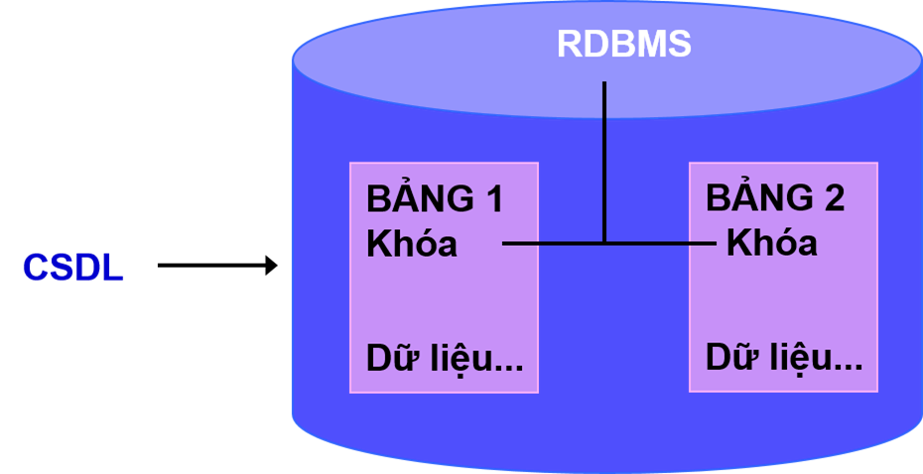

**Users related to RDBMS**

**Database Administrator, DataBase Designer, System Analyst, Application Programmer, Database Designer and Implementer (DBMS Designer and Implementer) ), End Users.**

**(Trình bày kiểu gì đây?)**

**II. Design relational database system.**

**Here I will present the database based on the requirements of LibraryManagement:**

**1. ERD**

**The database will have 5 tables corresponding to: Author , Book , People , Library**

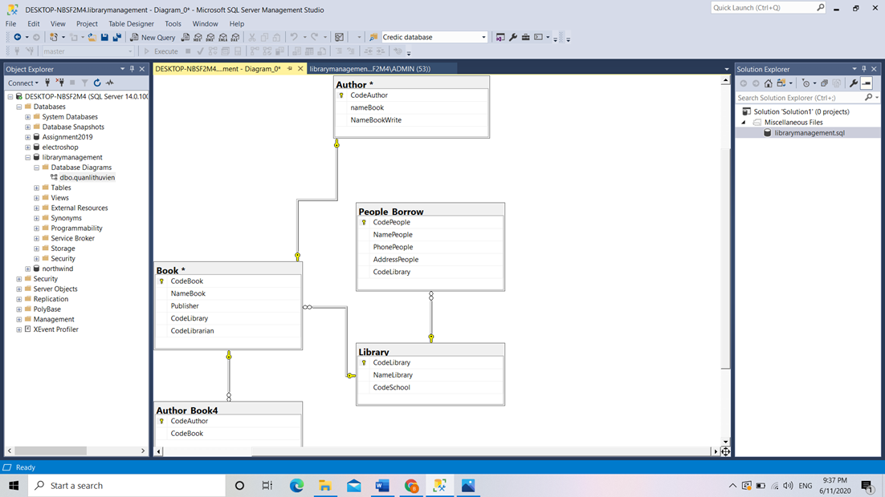

**(Sao bảng Book và Author lại có dấu * thế kia? Quan hệ sai rồi)**

**Book và Author quan hệ nhiều-nhiều**

**2. Design database.**

**On my assignment, I use SQL Server 2017 software for database creation.**

**Step 1: Create new database**

**(Cách để làm gì đây?)**

**CREATE DATABASE LibraryManagement**

**GO**

**CREATE TABLE School (Bảng này tạo để làm gì, sao trong diagram ko có)**

**(**

**CodeSchool int PRIMARY KEY NOT NULL,**

**NameSchool nvarchar(1000),**

**AddressSchool nvarchar(1000),**

**PhoneSchool nvarchar(1000),**

**)**

**CREATE TABLE Library_**

**(**

**CodeLibrary int PRIMARY KEY NOT NULL,**

**NameLibrary nvarchar(1000),**

**CodeSchool int FOREIGN KEY REFERENCES School(CodeSchool),**

**)**

**S Code to SQL Server:tep 2: Create people tables, books, library, author, with the corresponding data types. (Vừa sai tiếng Anh, vừa viết lung tung, ko đọc trước khi nộp)**

**Code to SQL Server:**

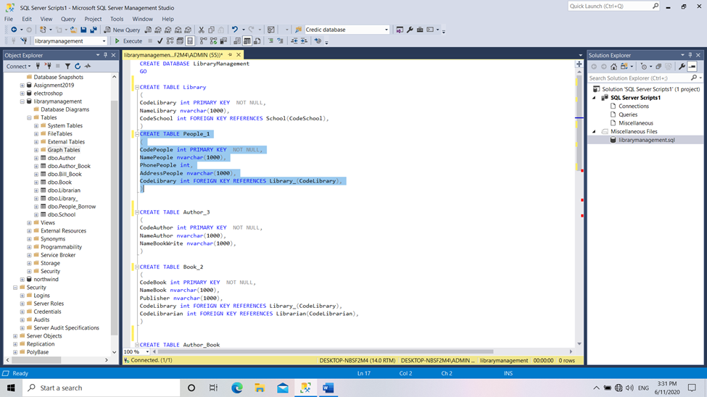

**-Create table “people”: (Lấy cái hình ở đâu ra? Có tạo bảng giống thế ko?)**

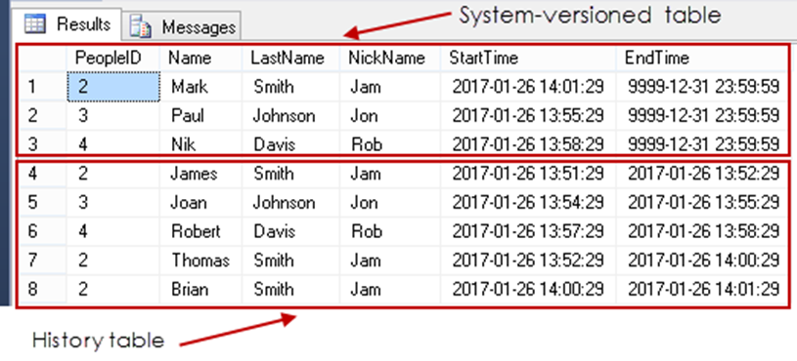

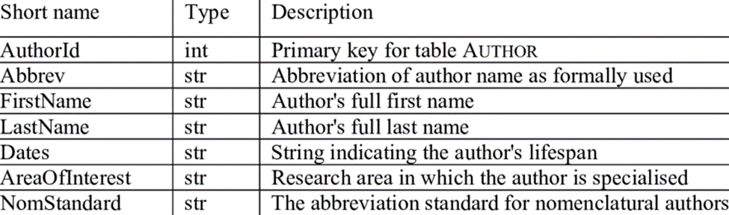

**-Create table “author”:**

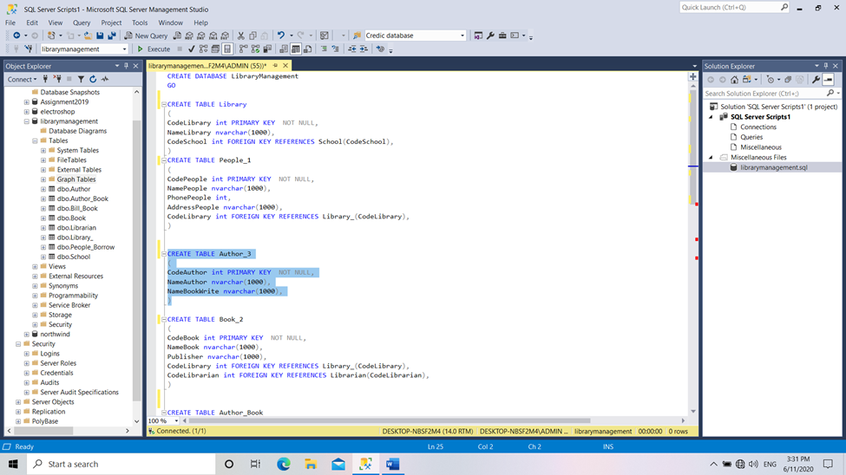

**Code to SQL Server:**

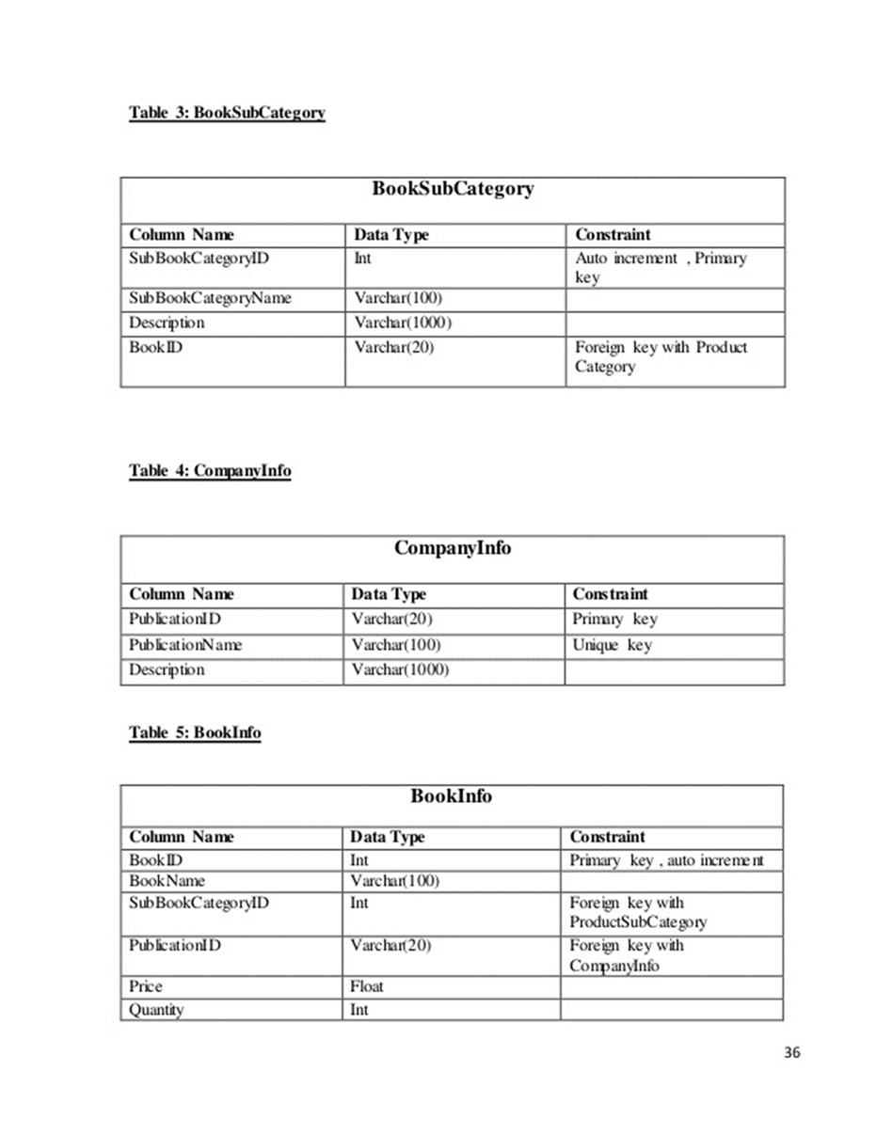

**(Lại lấy bảng ở đâu ra? E tạo bảng thế nào thì chụp dữ liệu bảng của mình ra chứ?)**

**-Create table “library”:**

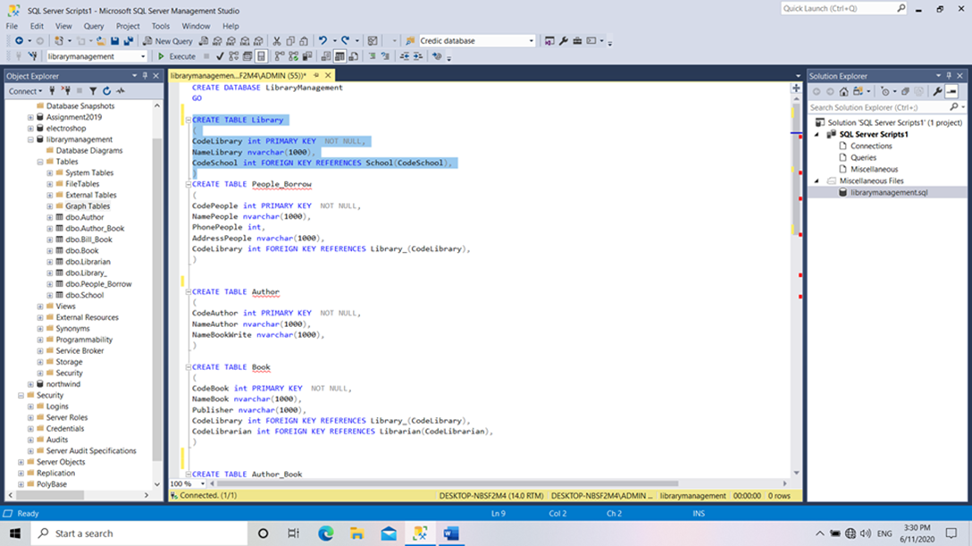

**Code Sql Server: (Cái hình dưới ở đâu ra? Nếu ko phải dữ liệu của mình thì bài điểm F nhé)**

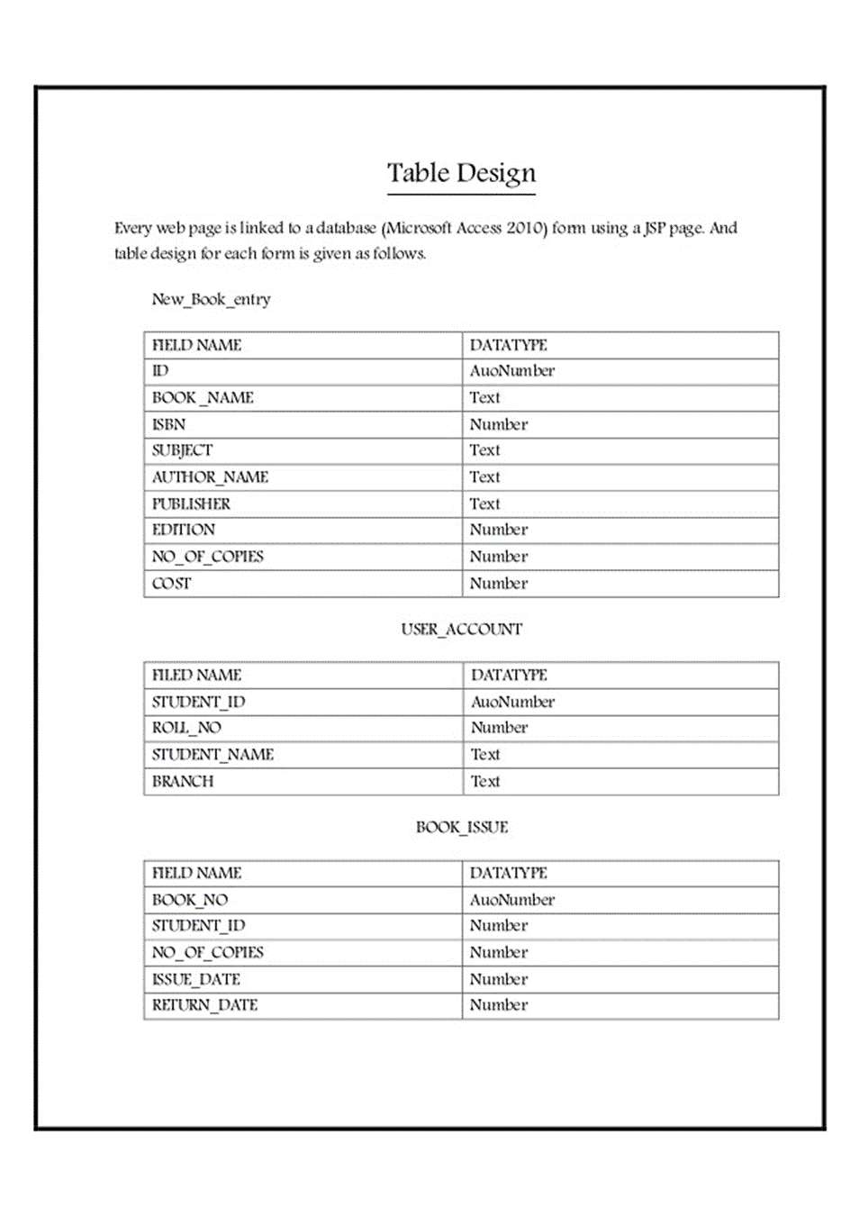

**Create Table : “Book”**

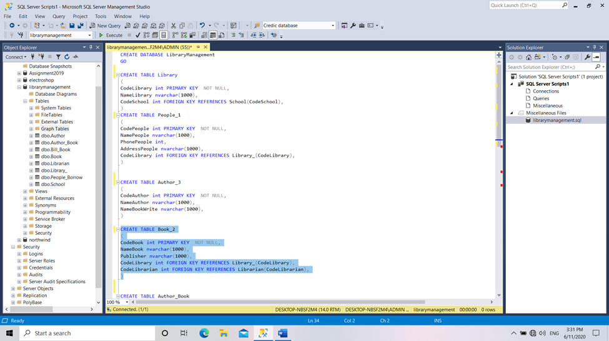

**Code SQL**

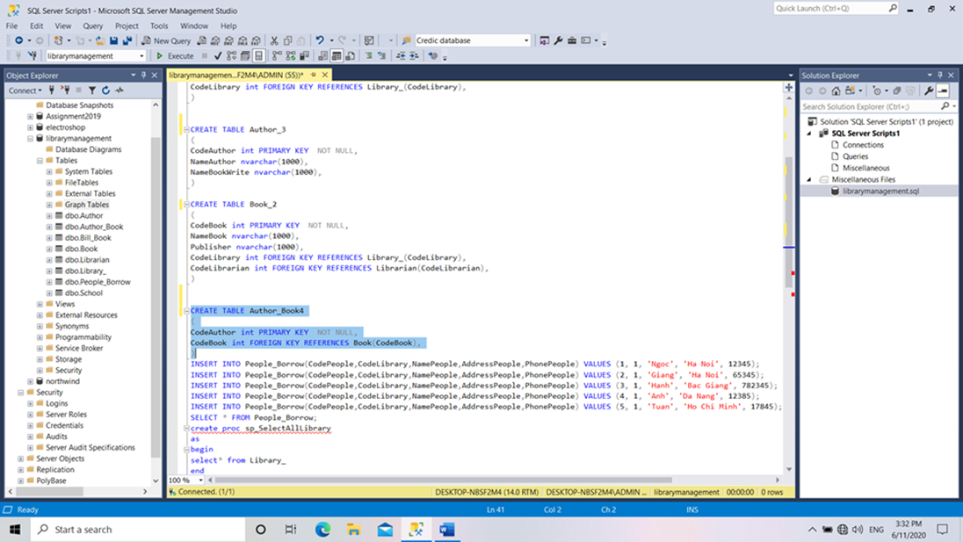

**Query statement in SQL**

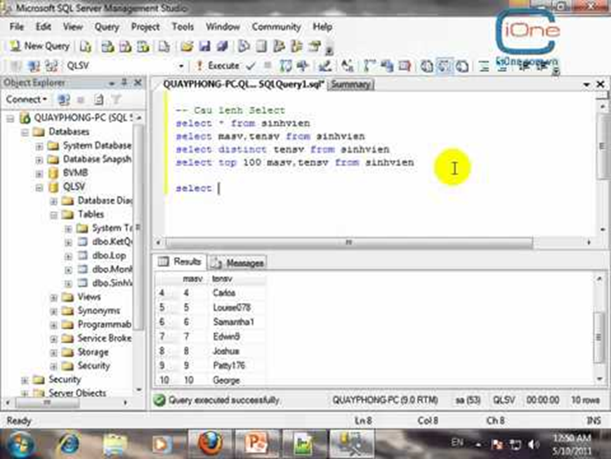

**(Hình này chép ở đâu ra?)**

**select statement in SQL**

**(Câu lệnh sai hết)**

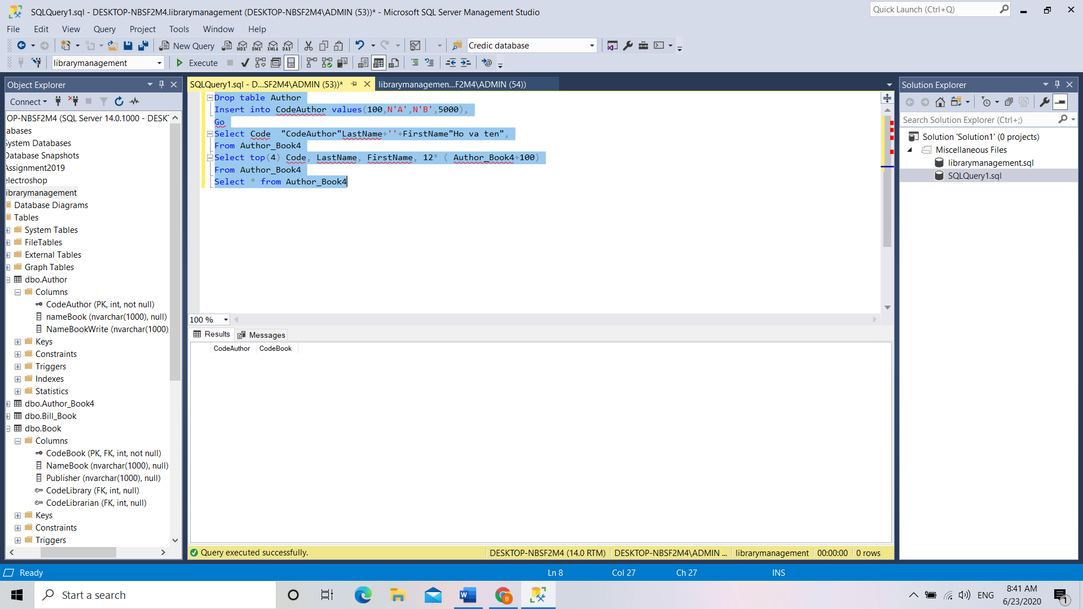

**select from query in SQL**

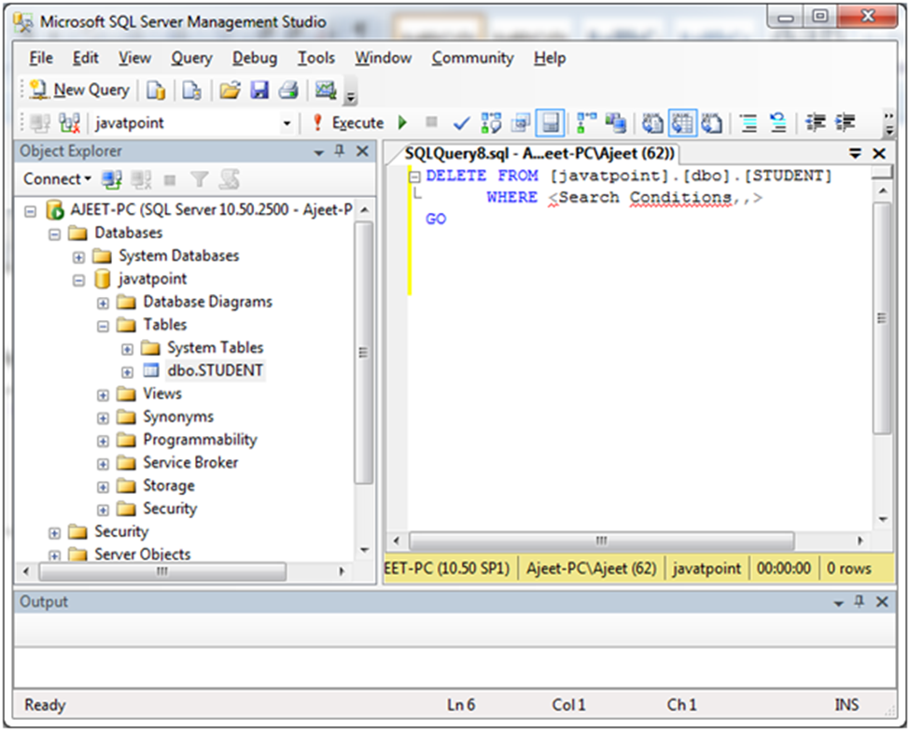

**(Lấy đâu ra hình này?)**

**statement delete data in SQL**

**(Cái gì đây sao ko có nội dung)**

**Those are basic statements in SQL**

**- basic query statement**

**- Insert Into statement**

**- select statement**

**- Delete statement**

**III:** **Practice (Không phải code của mình và ko hiểu thì điểm F e nhé)**

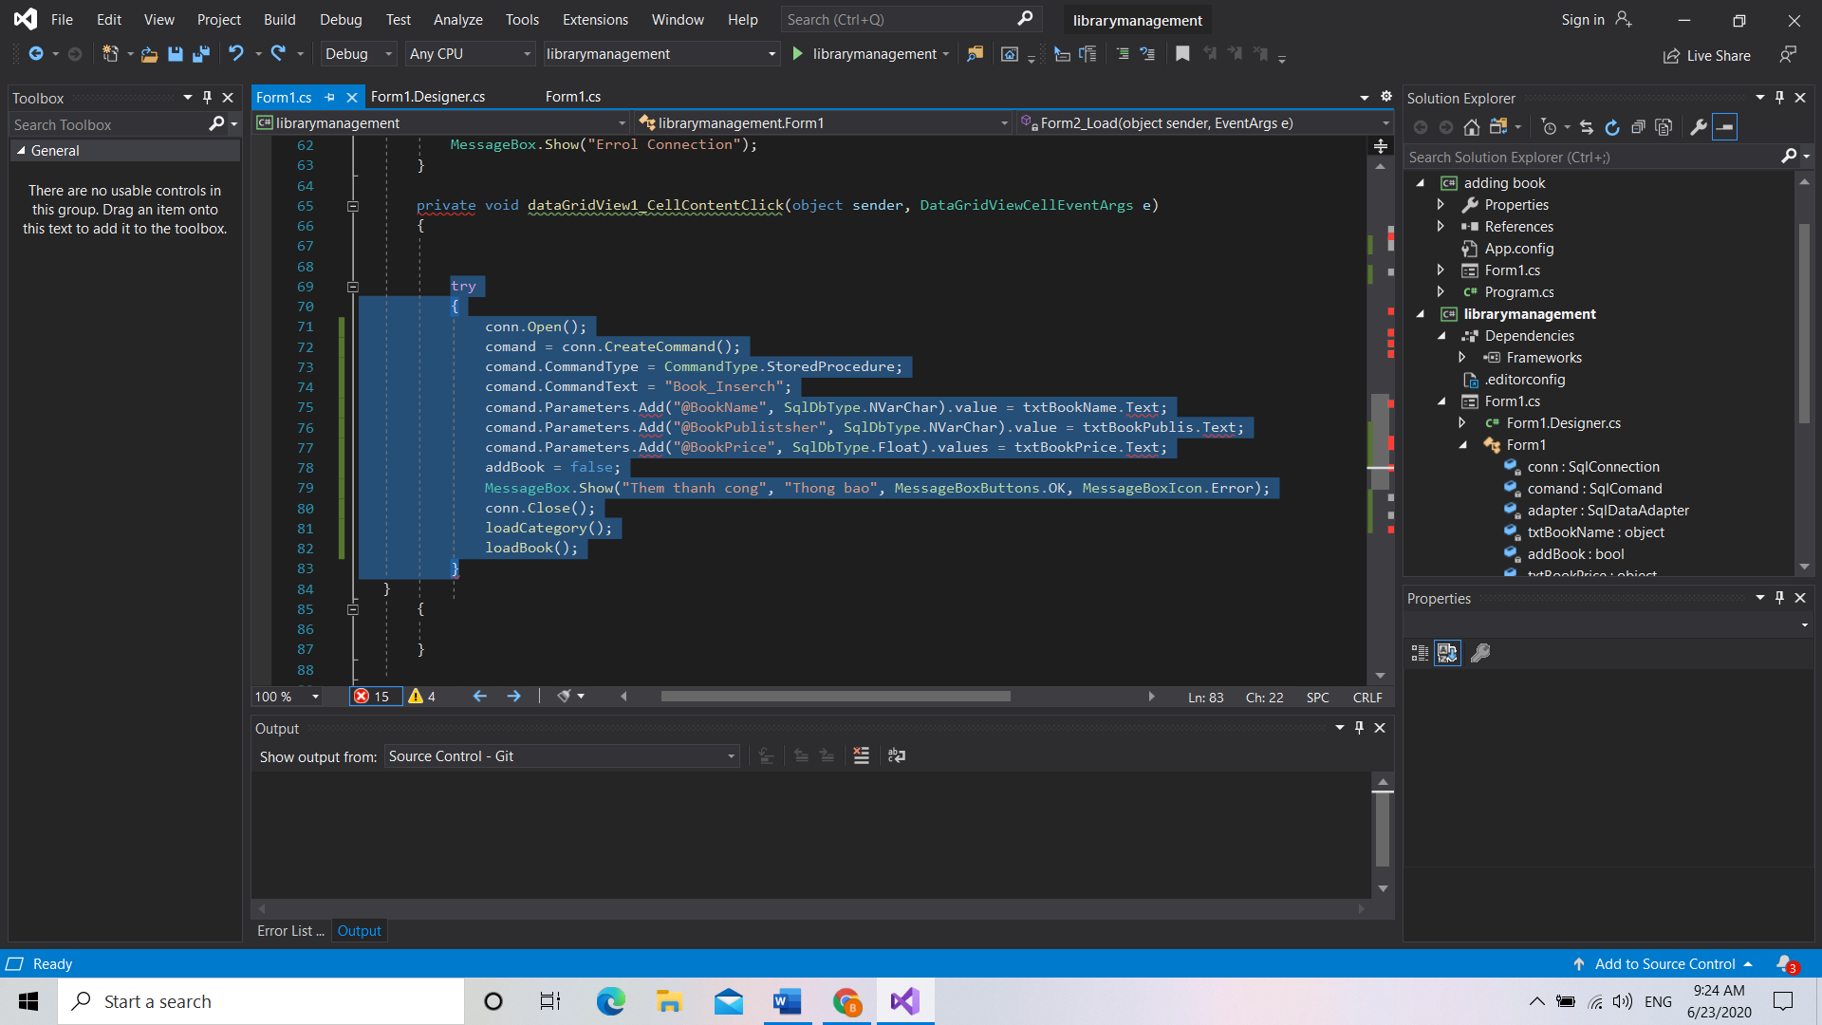

**Adding Books In Visual Studio**

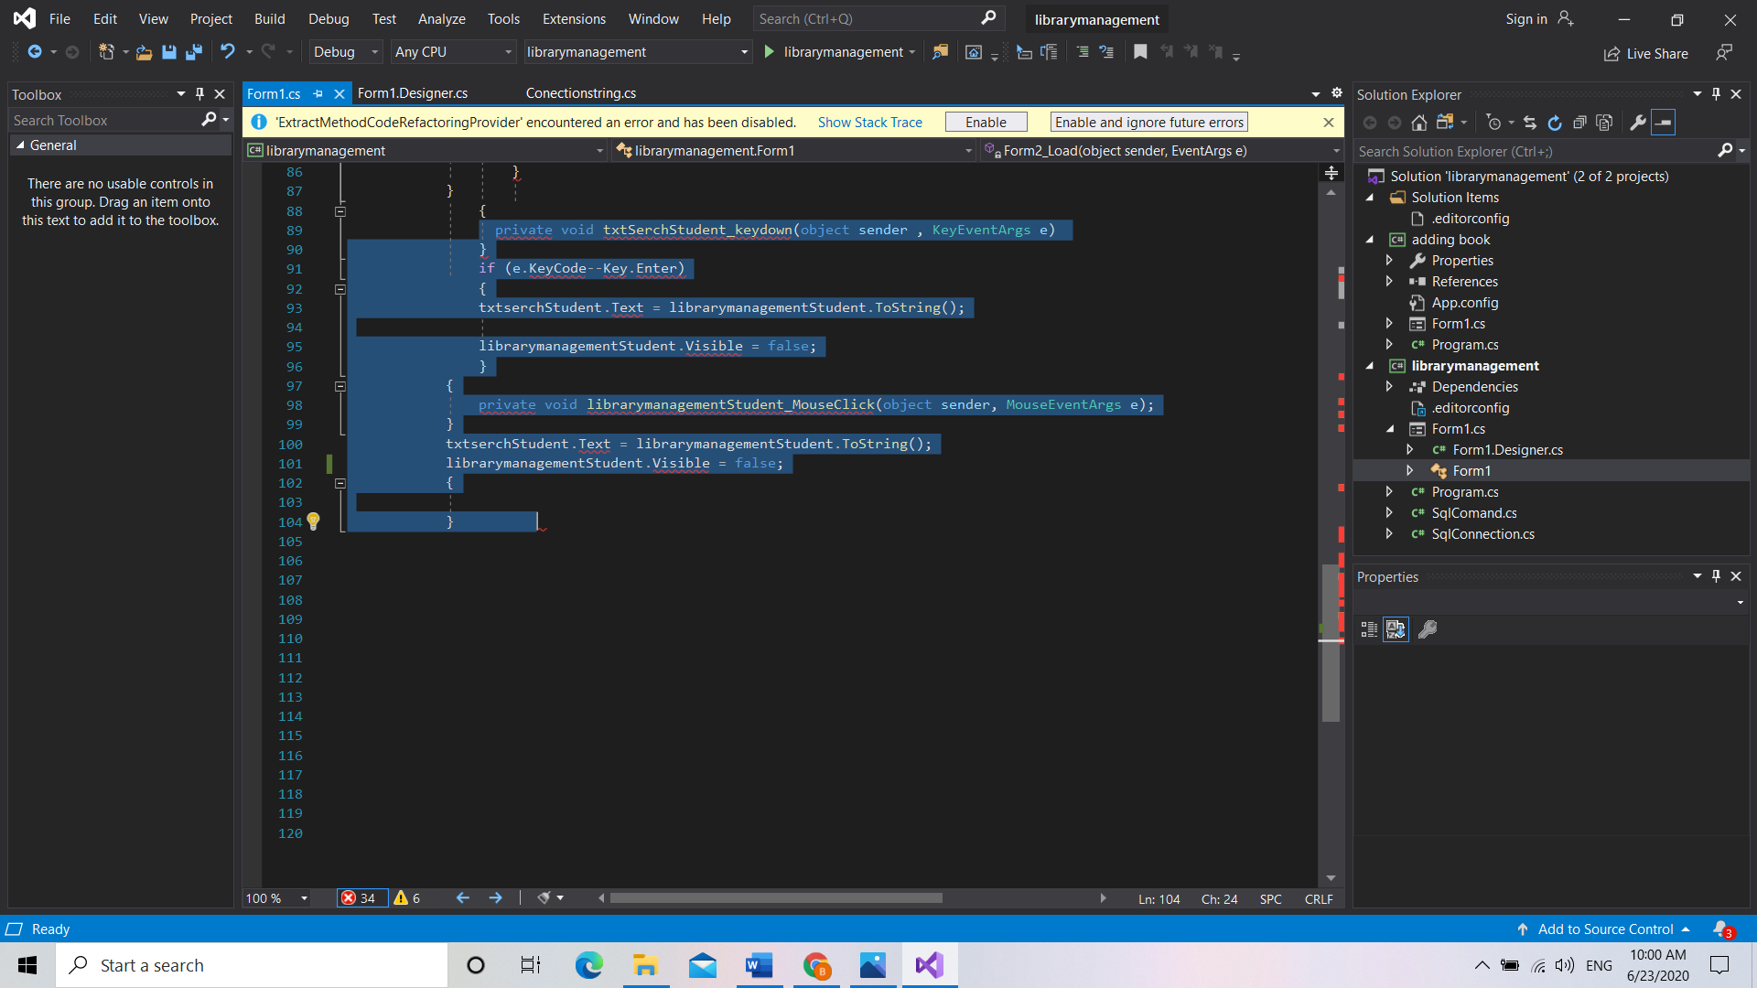

**Statement In Visual Studio**

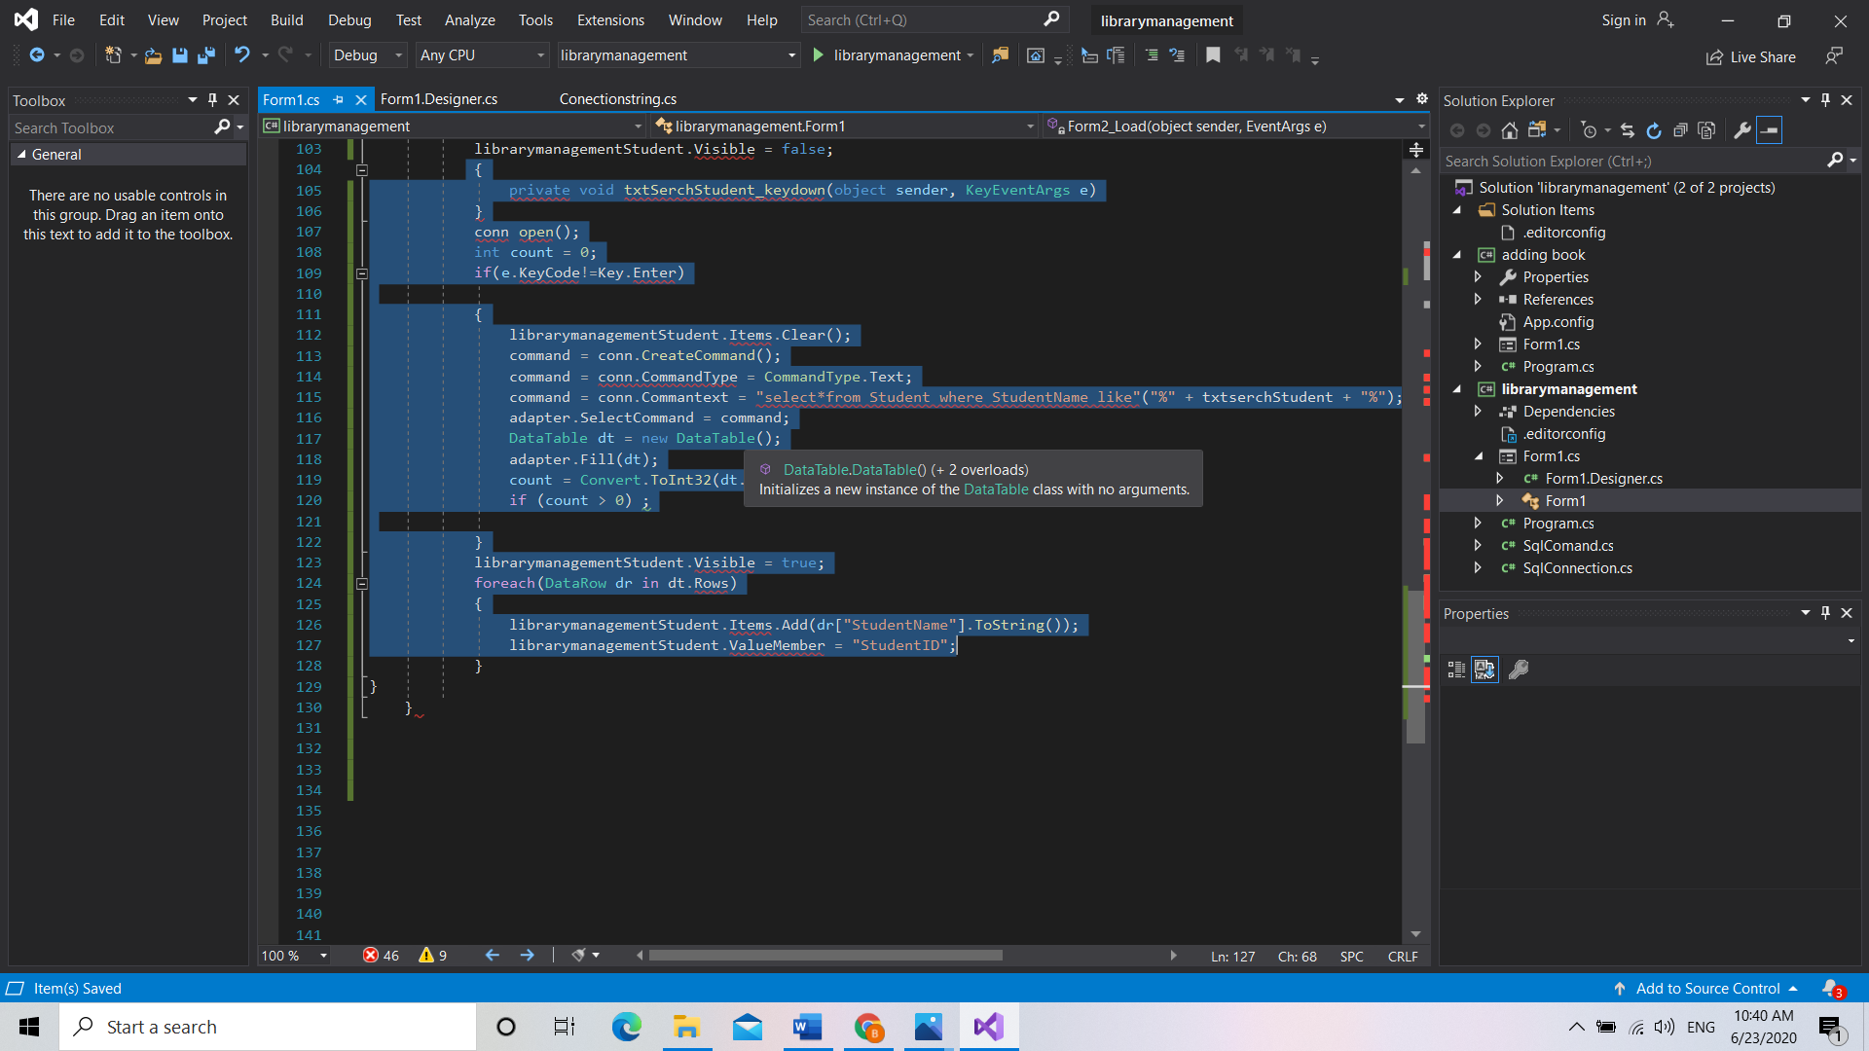

**Query Statement In Visual Studio**

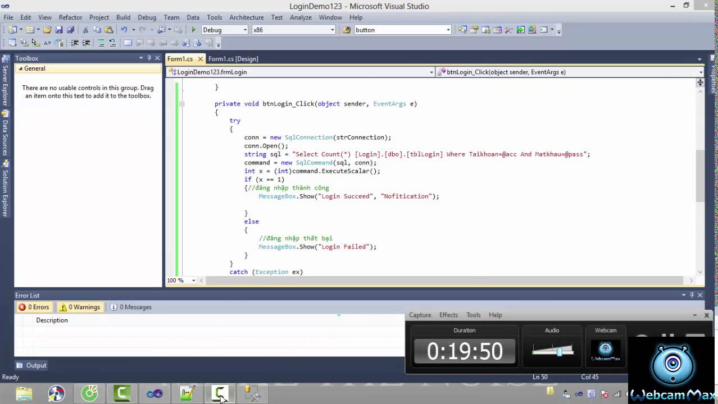

**Login Statement In Visual Studio**

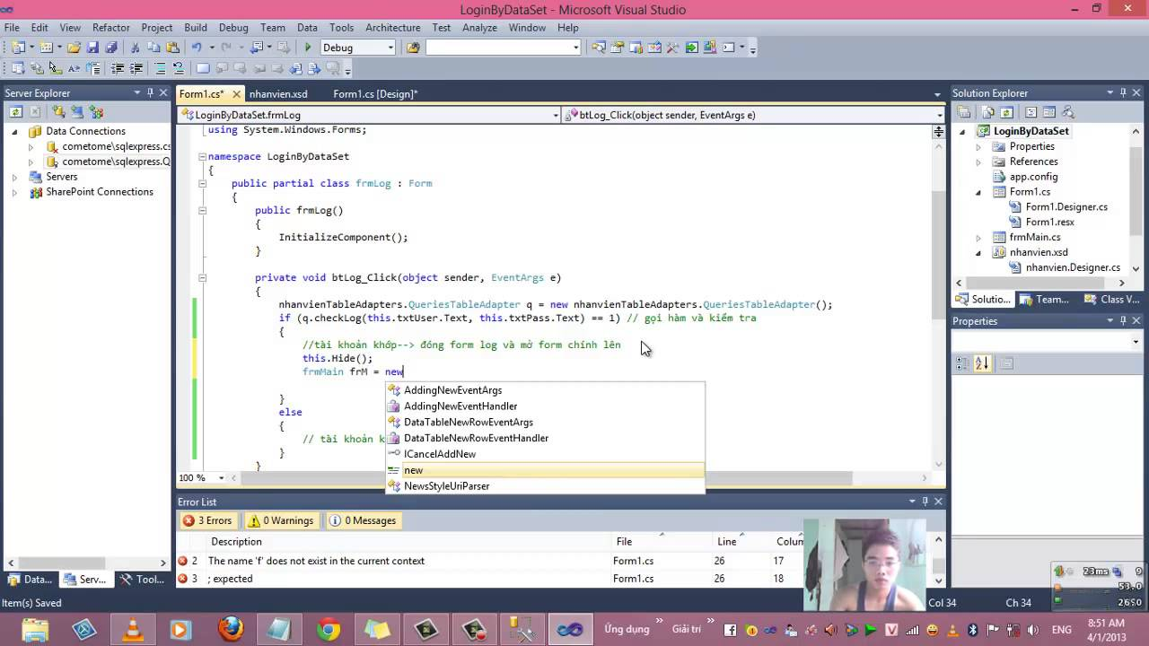

**Create Basic Login Form In Visual Studio**

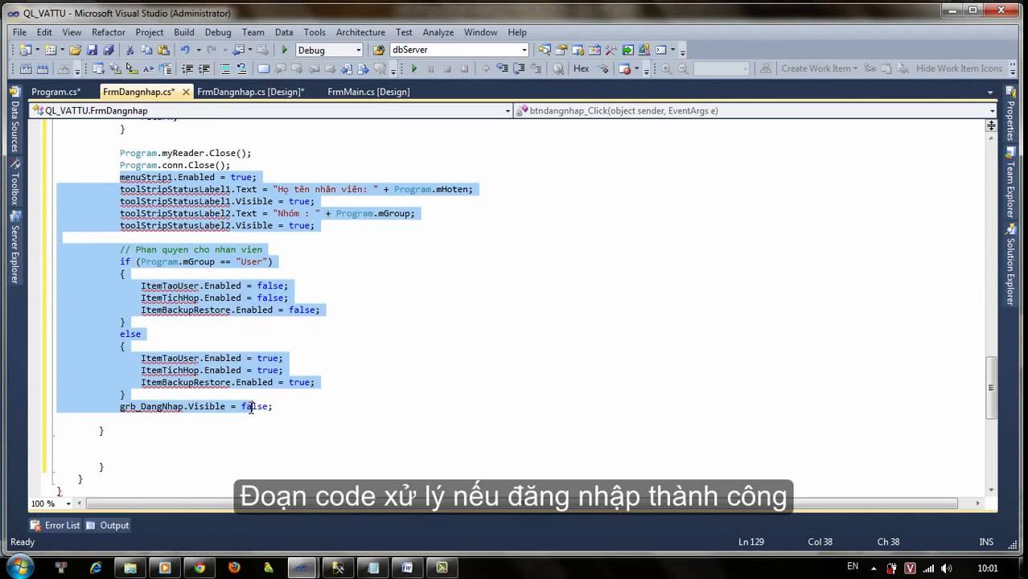

**Decentralized Form In Visual Studio**

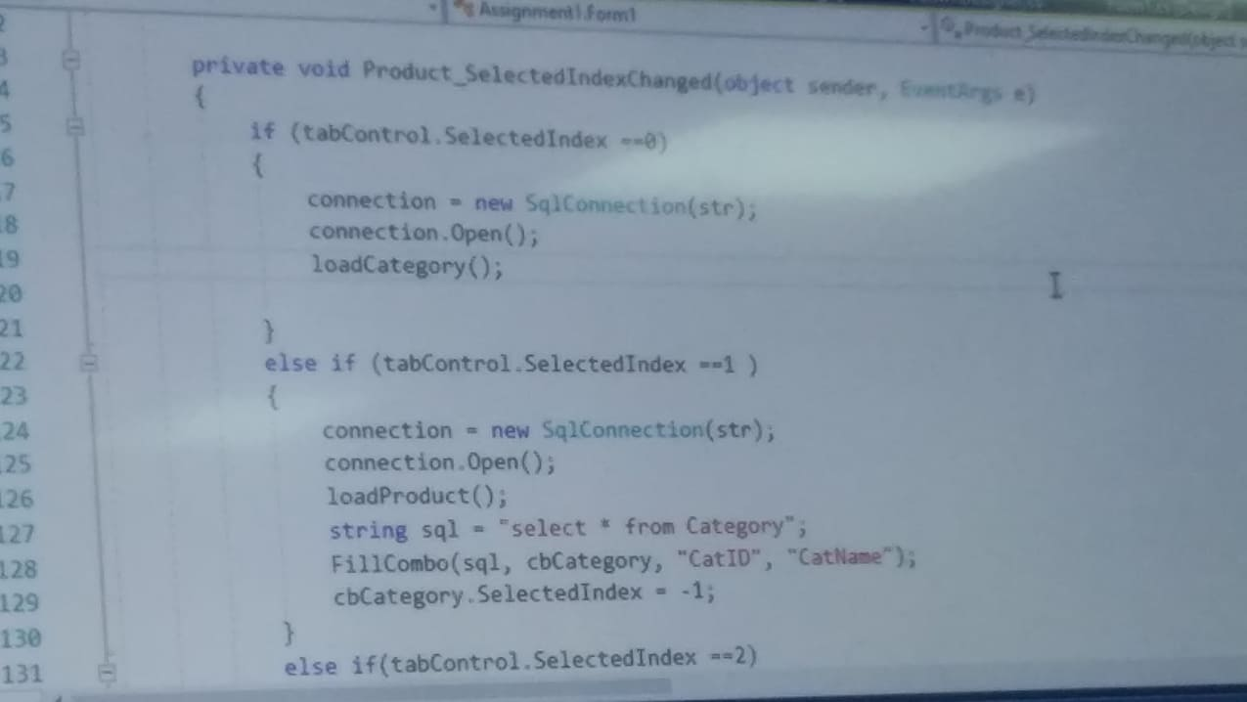

**Open Data Link Command In Visual Studio**

**1. Form Login (Toàn bộ giao diện phải của mình và khớp với thiết kế cơ sở dữ liệu)**

**- create an interface with the winform and features of the interface.**

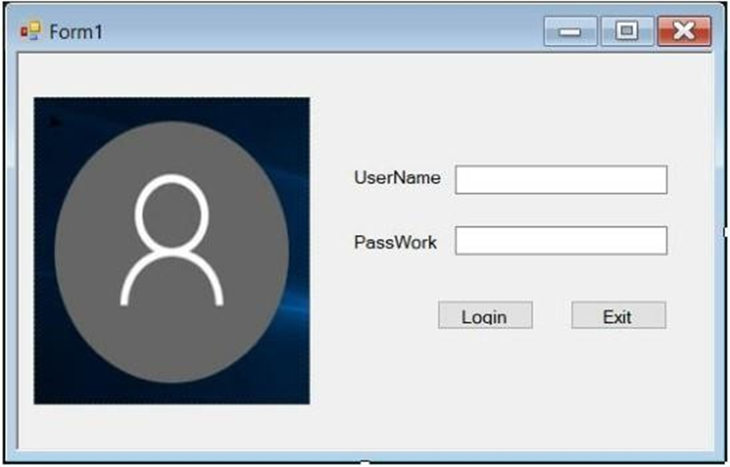

**- This is the login interface that allows customers to log in to the data form**

**+ If the user wants to log in, the user must have a username and password, the**

**user and passworld will be able to retrieve data from the SQL Sever database.**

**+ When the user logs in to the user and password, press the Login button to check**

**the information if the user and password are correct, the login interface will show a**

**message (OK).**

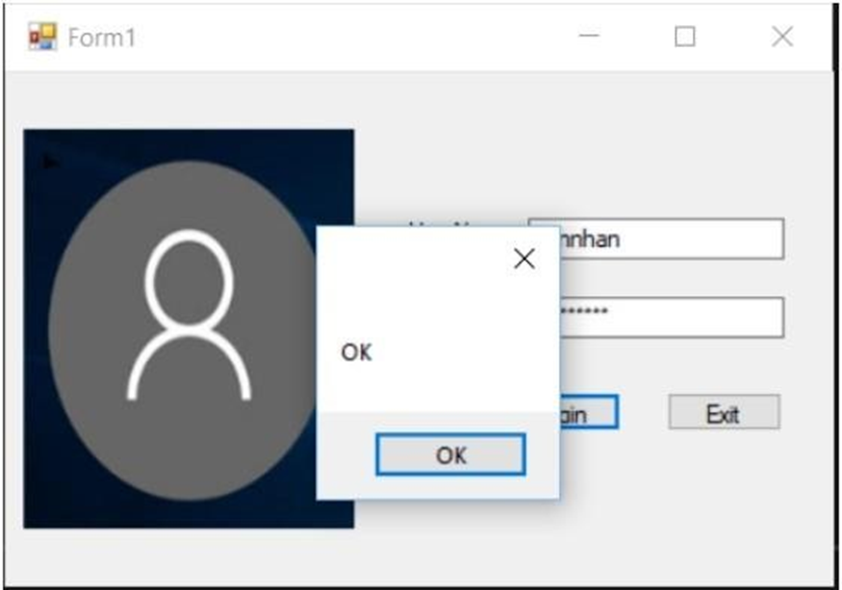

**1.2 Logged in successfully**

**+ If the user and password of the user are logged in incorrectly, the message will be displayed (Check your user or password).**

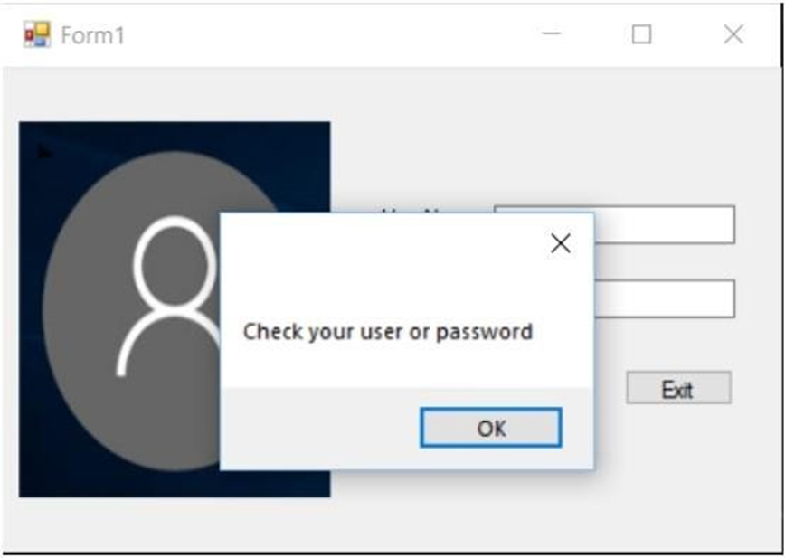

**1.2 login unsuccessful**

**+ If the user and password of the user are logged in incorrectly, the message will be displayed (Check your user or password).**

**2.** **-** **Selecting the function will go to the Library Management page.**

**(Toàn bộ giao diện phải của mình và khớp với thiết kế cơ sở dữ liệu)**

**In the customer management function, there will be 4 functions: search, add, delete, update. Form Library**

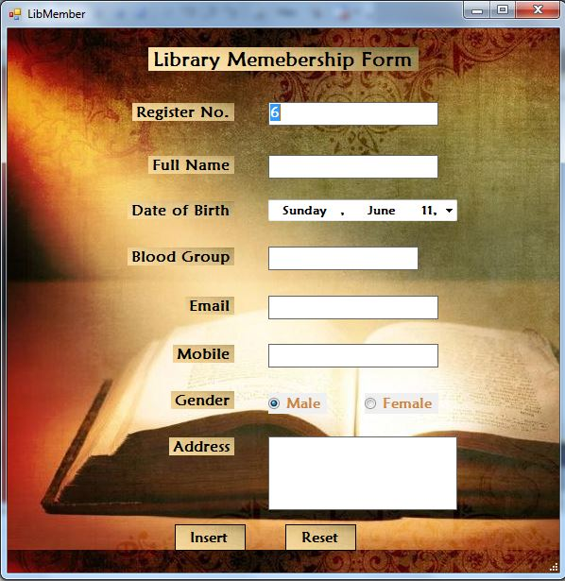

1. **Form Library Manage**

**- The search button is used to search for information of Libray that users want to find**

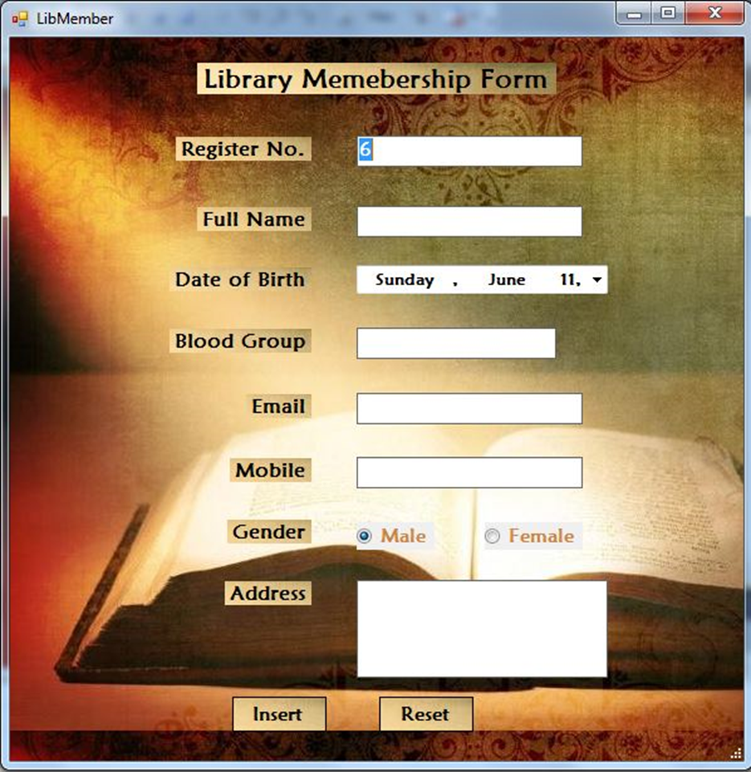

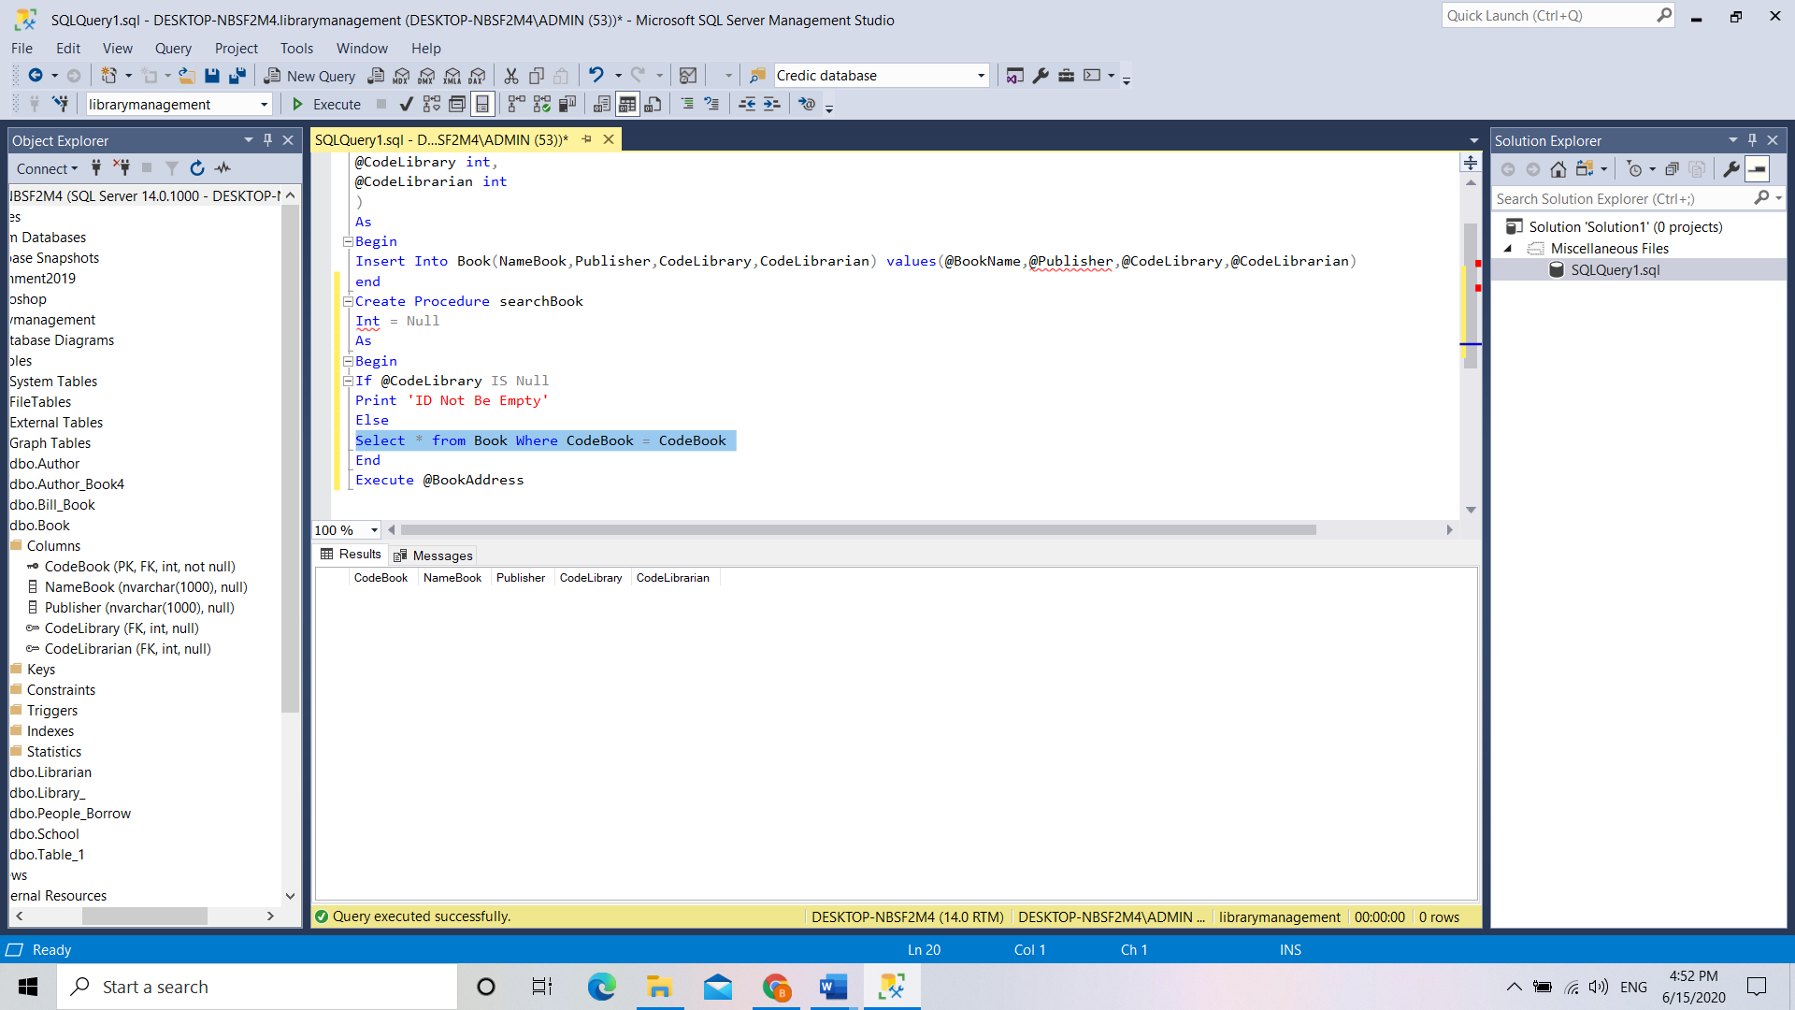

**a. Function Search**

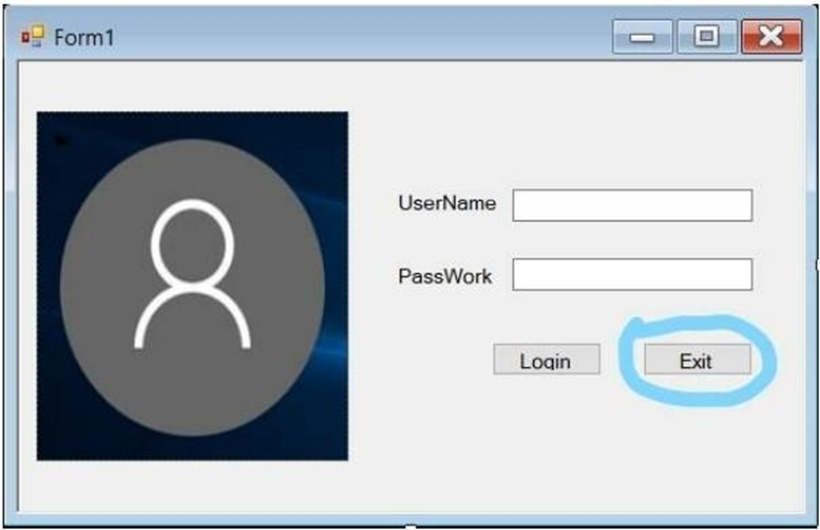

**1.3 exit the login interface**

**+ If the customer wants to exit the login interface, it is possible to press the button (Exit) next to the (Login) button to turn off the login interface.**

**- The Add button is used to add Library Management to the data**

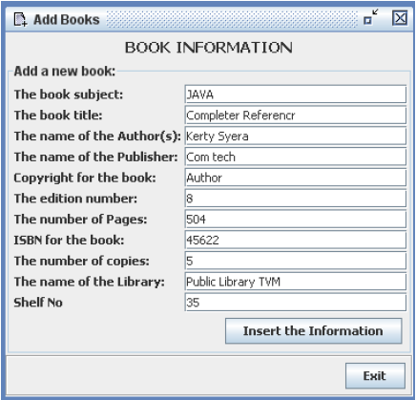

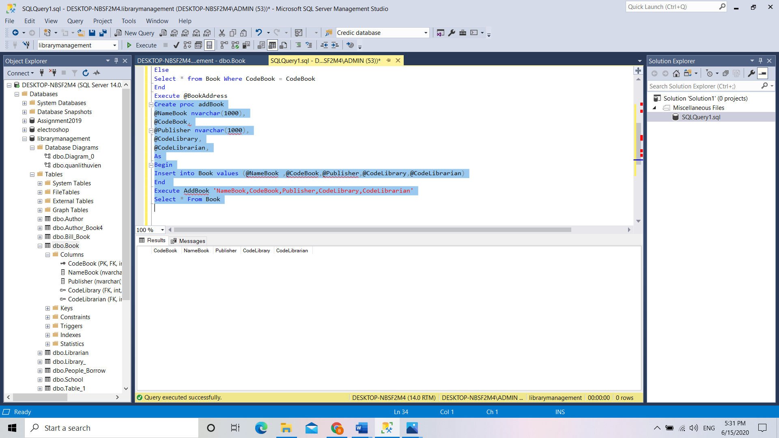

**b. Function Add**

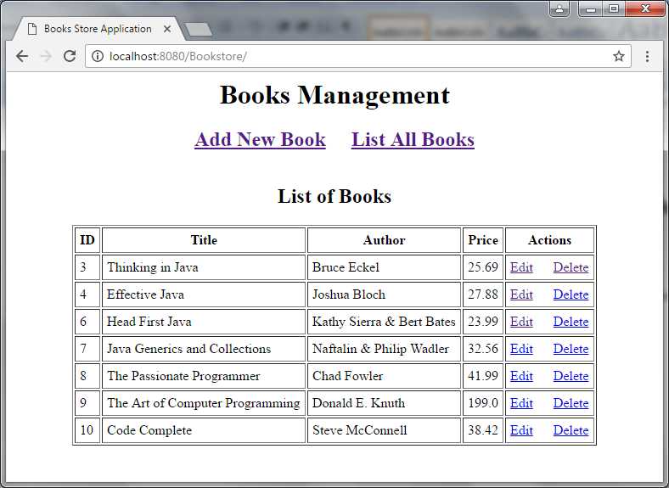

**- Delete button is used to delete LibraryManagement from the data**

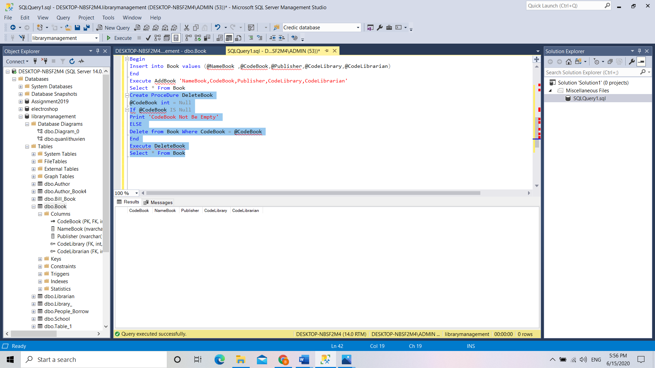

**c. Function Delete**

**- The Update button is used to add data to a certain Library whose information is missing.**

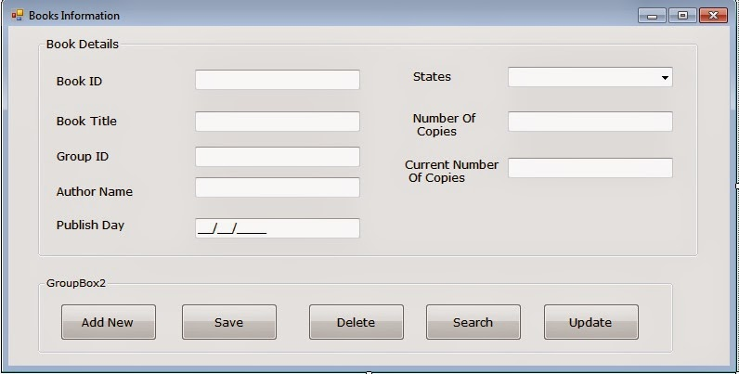

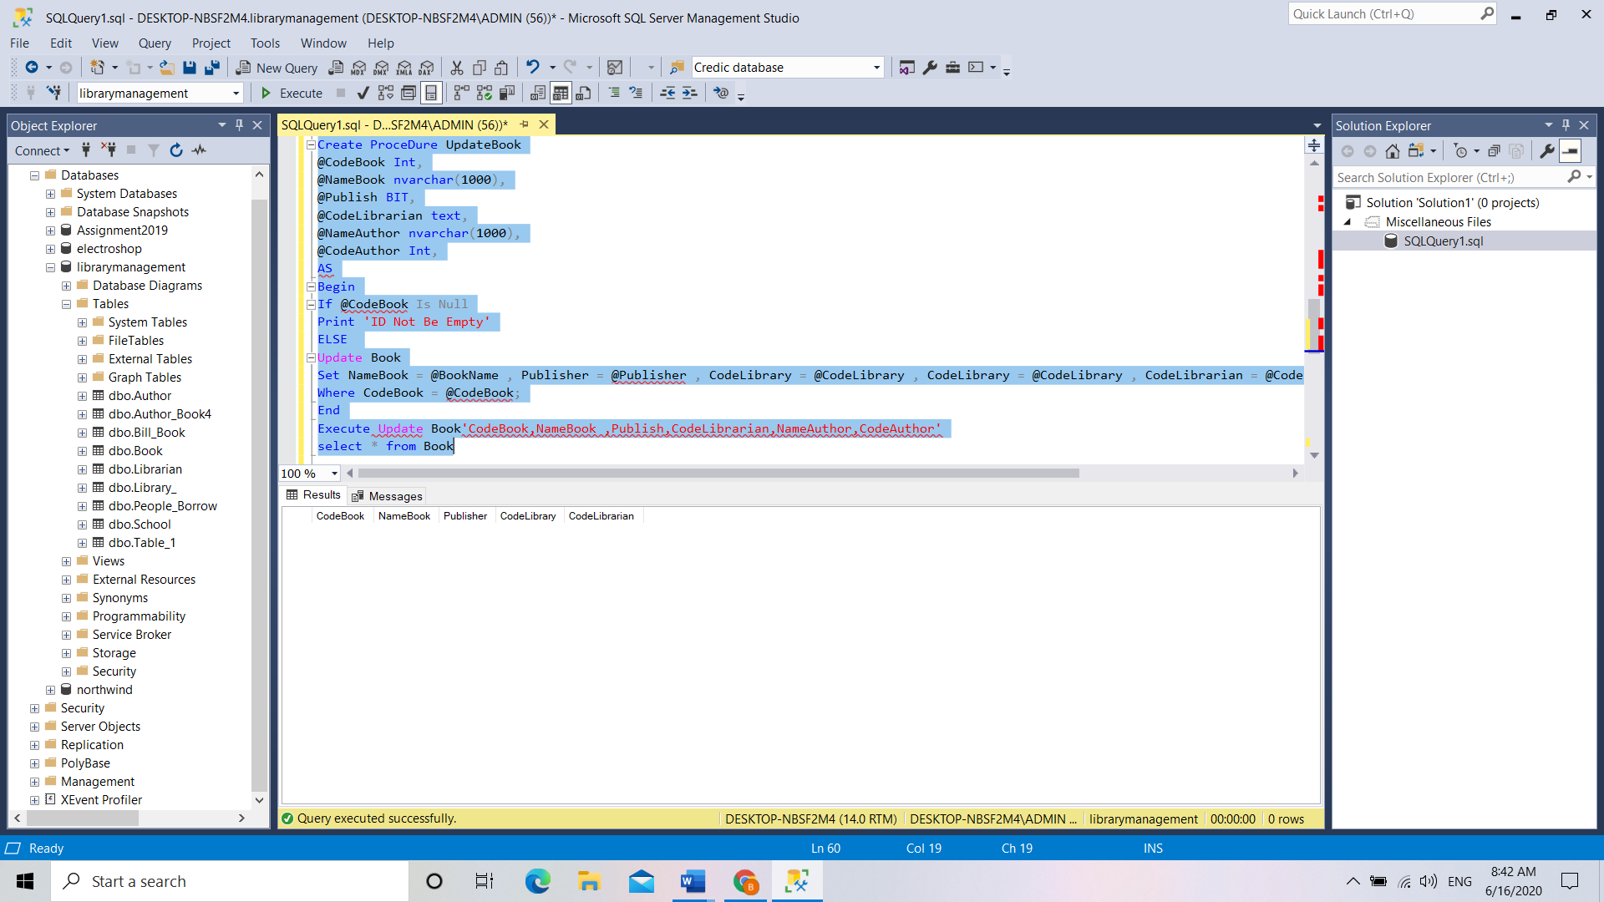

**d. Function Update**

**IV. User manual**

**1. Login**

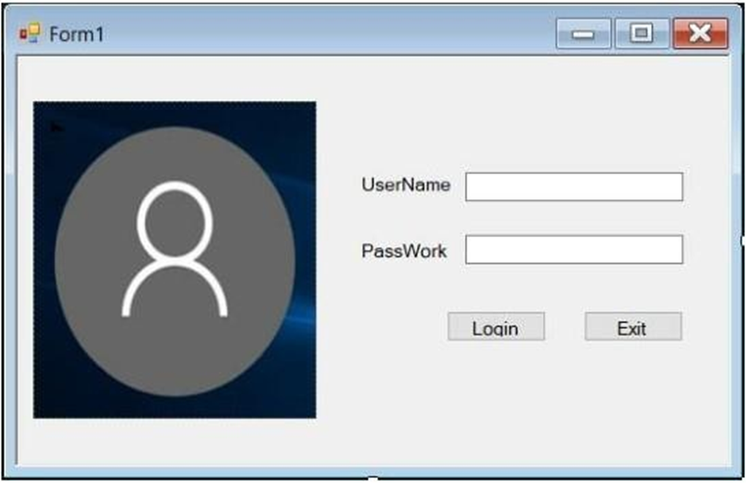

**- How to use Login form**

**+ Step 1: Please post userName and PassWord**

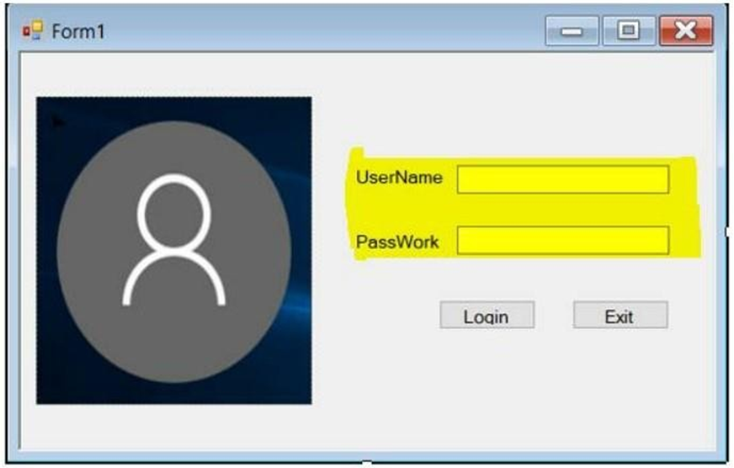

**+ Step 2: When the user enters UserName and PassWord, press the Login button.**

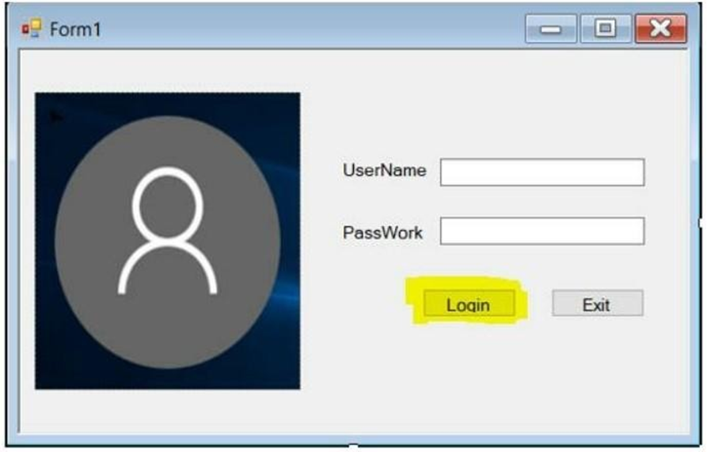

**2.** **Form LibraryManagement**

**a. Search function**

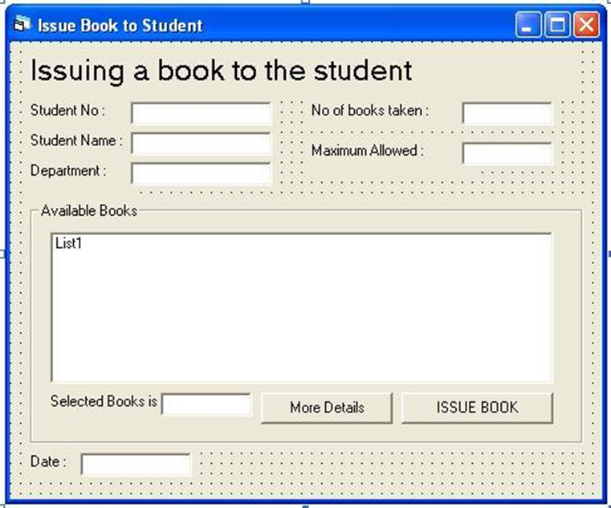

**• On this "LibraryManagement" page you will have 4 more functions that are searching, adding, deleting, updating.**

**• You want to find Book information, you have 2 choices: enter the CodeBook and enter the name of the Book.**

**• You enter the CodeBook or name, the data will show up on datagirdview**

**b. Add function**

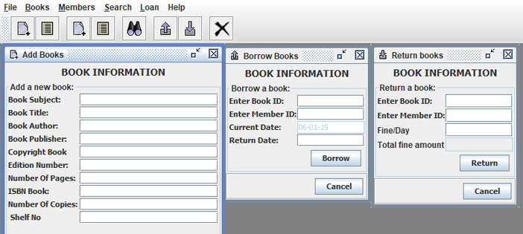

**• You want to add Book data, you choose the add function. You enter the full information of the customer and then click the "Save" button, the data will be saved.**

**c. Delete function**

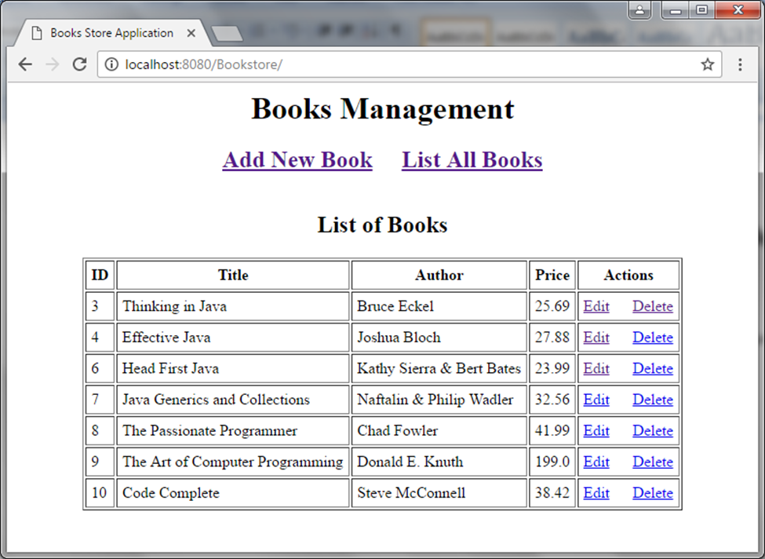

**• You want to delete Book data, you select the delete function. You enter ID or Name to display the Book. then click on the "Delete" button and there will be a message saying "Are you sure you want to delete it?" You press "Yes" to delete or "No" to cancel.**

**d. Update**

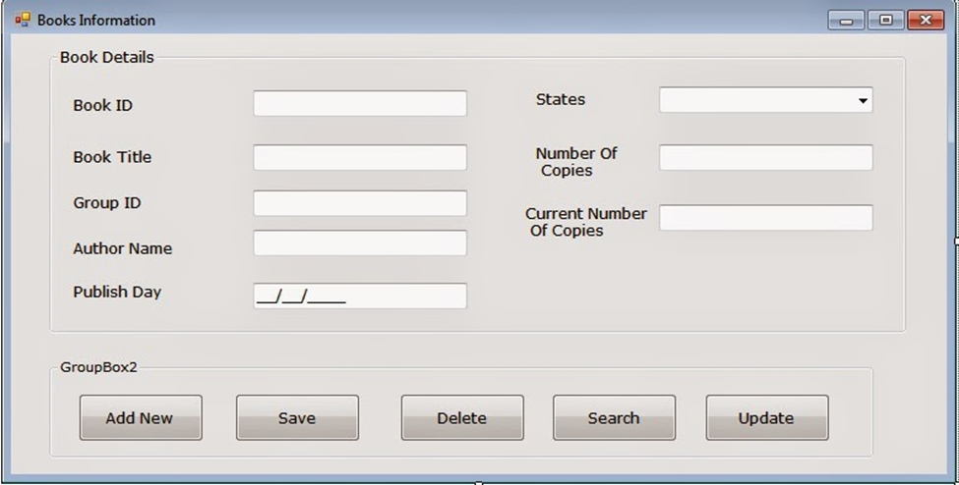

**3. View Bill_Book**

**You choose the function “View Bill_Book” then the screen will switch to the following page:**

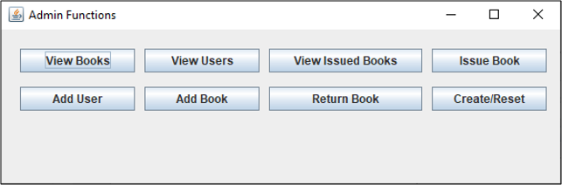

**• Search function is available in this function and you can choose 1 of 3 types of ID, BookName, LibraryManagement name to find.**

**• After you press the "search" button, your data will be displayed on datagirdview**

**V:** **Conclusion**

**This report has shown the basic concept of database systems, standardized forms of data. The report also uses SQL Server 2017 software to create a database for sales business based on requirements.**